Organic Shapes
# Source: AI Source: Provided by: [Data Path: Persons Table -> ID Column: 1, Name_En Column: Motasem Essam] -> From: [ChatGPT] on [7/25/2026]
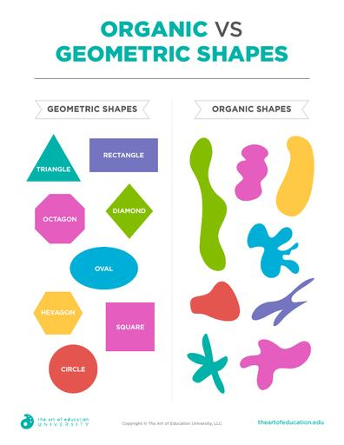
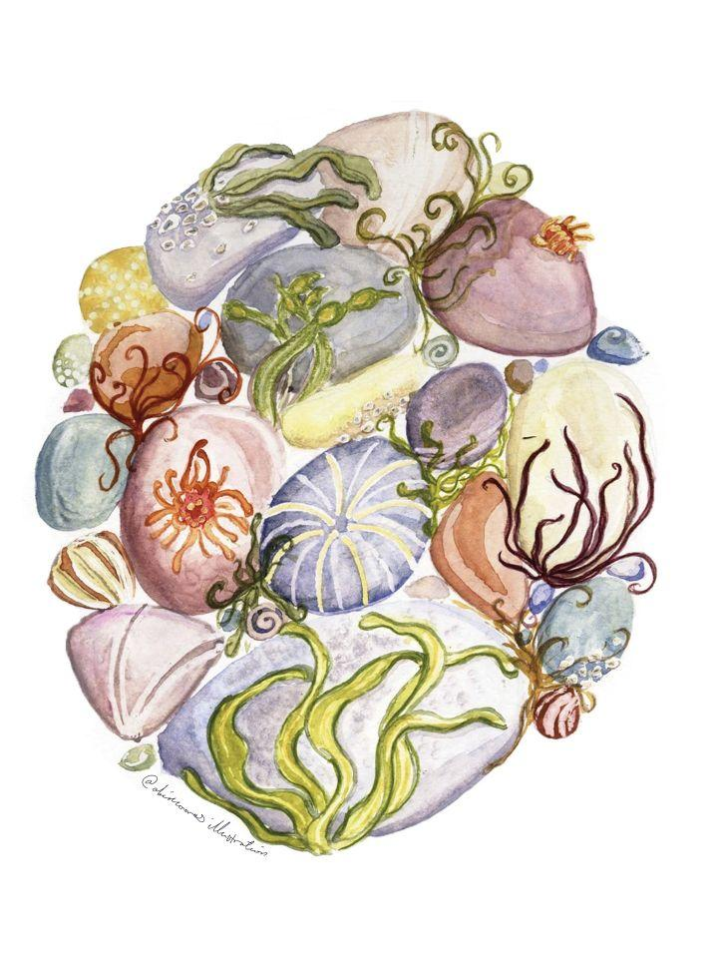
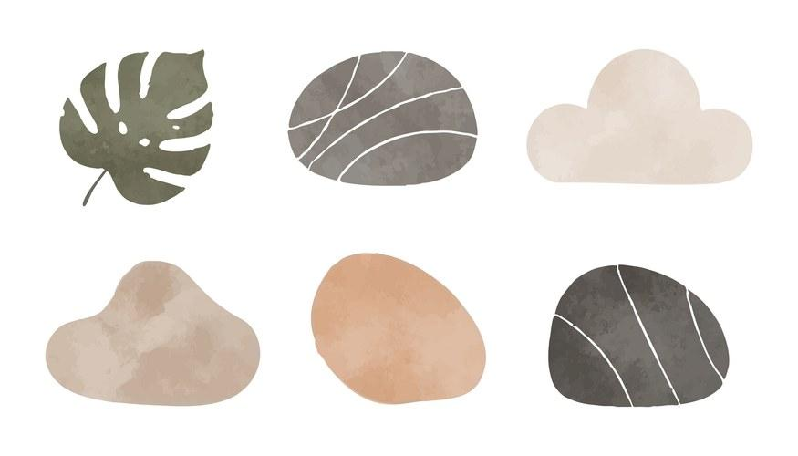
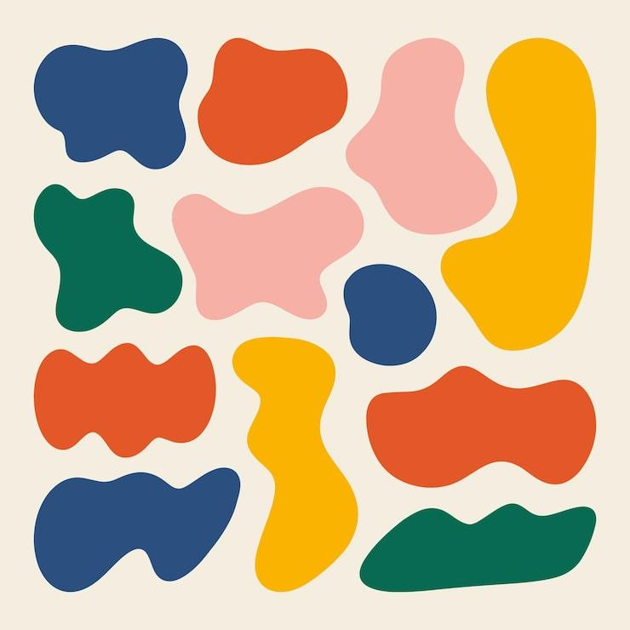
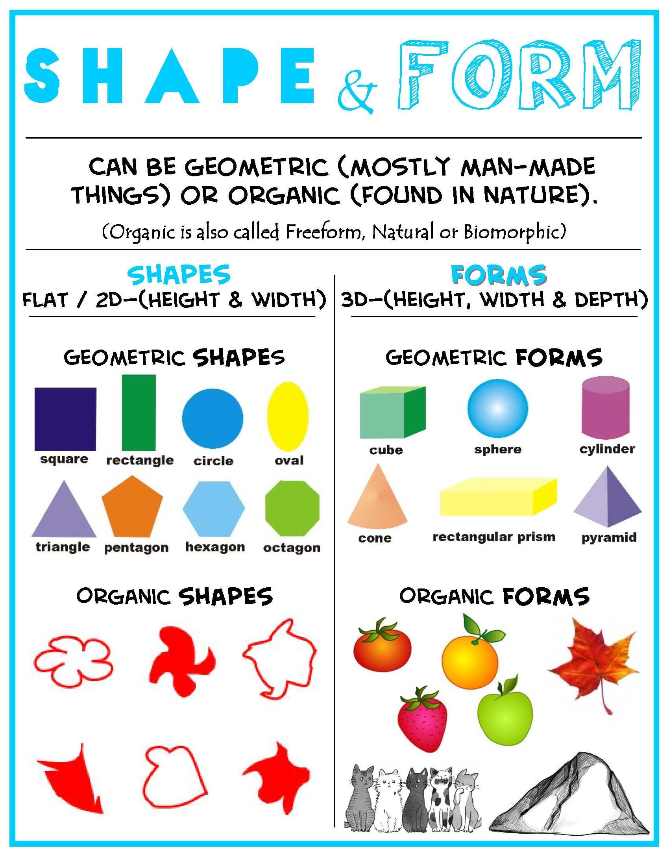
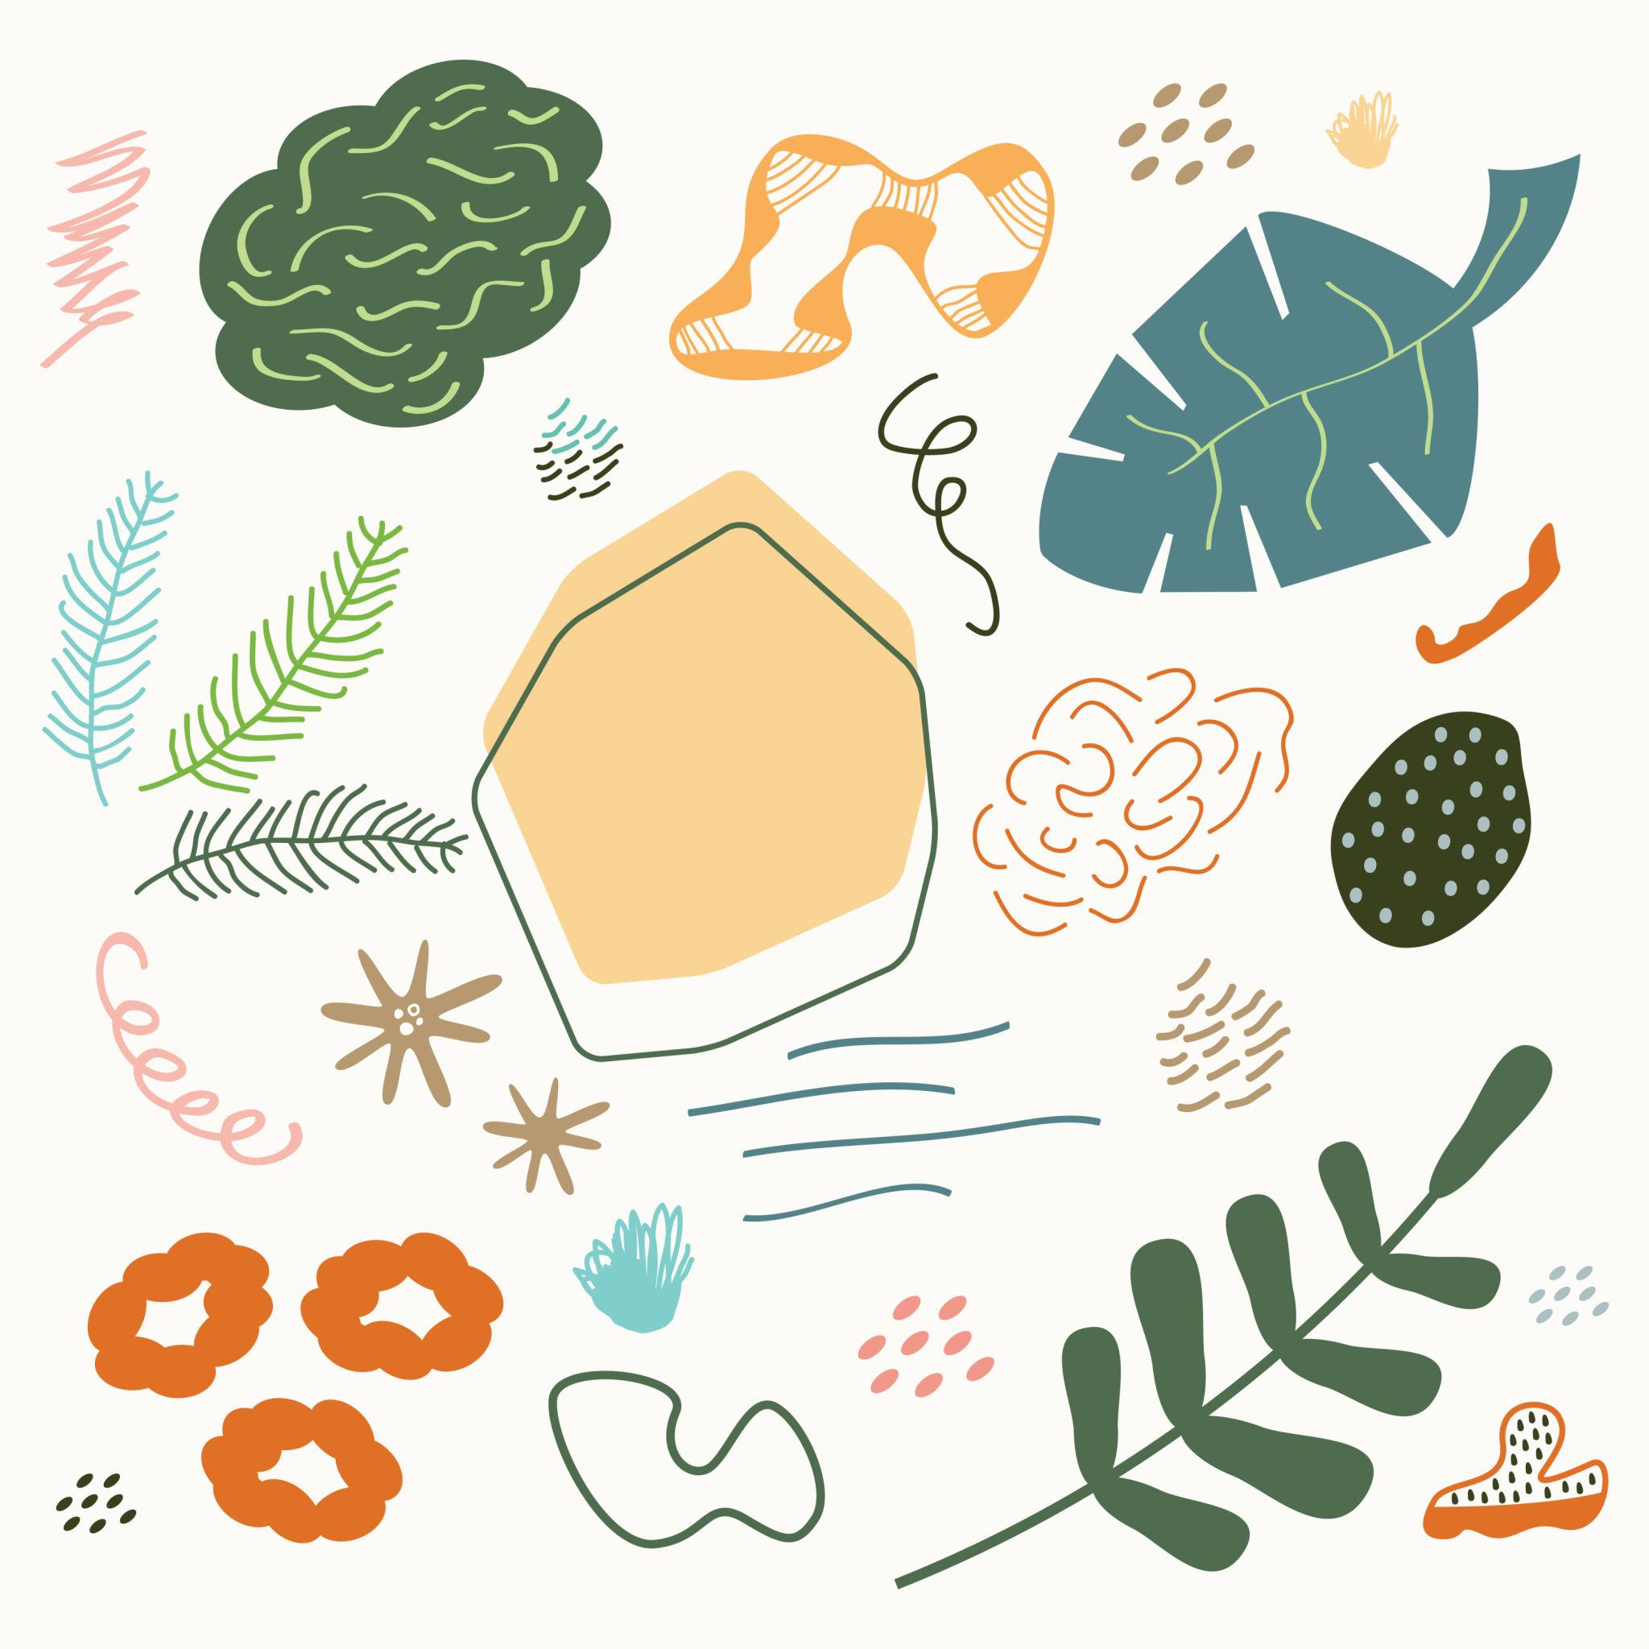

Definition
# Source: AI Source: Provided by: [Data Path: Persons Table -> ID Column: 1, Name_En Column: Motasem Essam] -> From: [ChatGPT] on [7/25/2026]
Organic Shapes are shapes that have irregular, natural, flowing, or free-form boundaries, often resembling forms found in nature.
Unlike geometric shapes, which are usually defined by precise mathematical properties, organic shapes generally do not have a fixed set of exact dimensions, angles, or regular boundaries.
Examples include shapes resembling:
- Leaves
- Clouds
- Flowers
- Stones
- Water splashes
- Trees
- Animals
- Human body parts
- Natural landforms

Fundamental Concept
# Source: AI Source: Provided by: [Data Path: Persons Table -> ID Column: 1, Name_En Column: Motasem Essam] -> From: [ChatGPT] on [7/25/2026]
Organic shapes are primarily characterized by their natural and irregular appearance.
They may contain:
- Curved boundaries
- Uneven edges
- Smooth transitions
- Irregular contours
- Asymmetry
- Free-form outlines
An organic shape does not have to represent a natural object. An artificially drawn free-form shape can also be described as organic if its boundary has a natural, irregular appearance.

Classification of Shapes
# Source: AI Source: Provided by: [Data Path: Persons Table -> ID Column: 1, Name_En Column: Motasem Essam] -> From: [ChatGPT] on [7/25/2026]
A broad classification is:
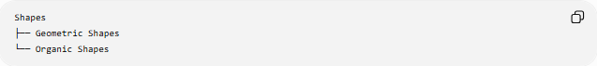
Shapes
├── Geometric Shapes
└── Organic Shapes
A more detailed classification is:
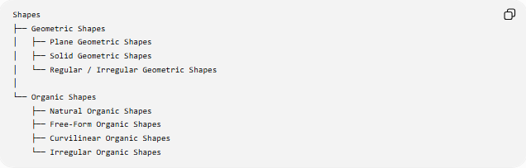
Shapes
├── Geometric Shapes
│ ├── Plane Geometric Shapes
│ ├── Solid Geometric Shapes
│ └── Regular / Irregular Geometric Shapes
│
└── Organic Shapes
├── Natural Organic Shapes
├── Free-Form Organic Shapes
├── Curvilinear Organic Shapes
└── Irregular Organic Shapes

Main Characteristics
# Source: AI Source: Provided by: [Data Path: Persons Table -> ID Column: 1, Name_En Column: Motasem Essam] -> From: [ChatGPT] on [7/25/2026]
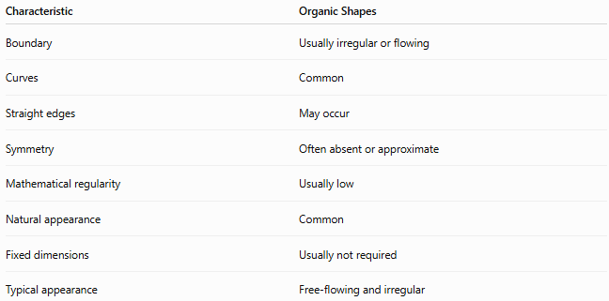
Characteristic | Organic Shapes
Boundary | Usually irregular or flowing
Curves | Common
Straight edges | May occur
Symmetry | Often absent or approximate
Mathematical regularity | Usually low
Natural appearance | Common
Fixed dimensions | Usually not required
Typical appearance | Free-flowing and irregular

Natural Organic Shapes
# Source: AI Source: Provided by: [Data Path: Persons Table -> ID Column: 1, Name_En Column: Motasem Essam] -> From: [ChatGPT] on [7/25/2026]
Natural Organic Shapes are shapes that resemble forms occurring naturally in the physical world.
Examples include:
- Leaf shapes
- Cloud shapes
- Pebble shapes
- Flower-petal shapes
- Tree-canopy shapes
- Animal silhouettes
- Waves
- Natural rock formations
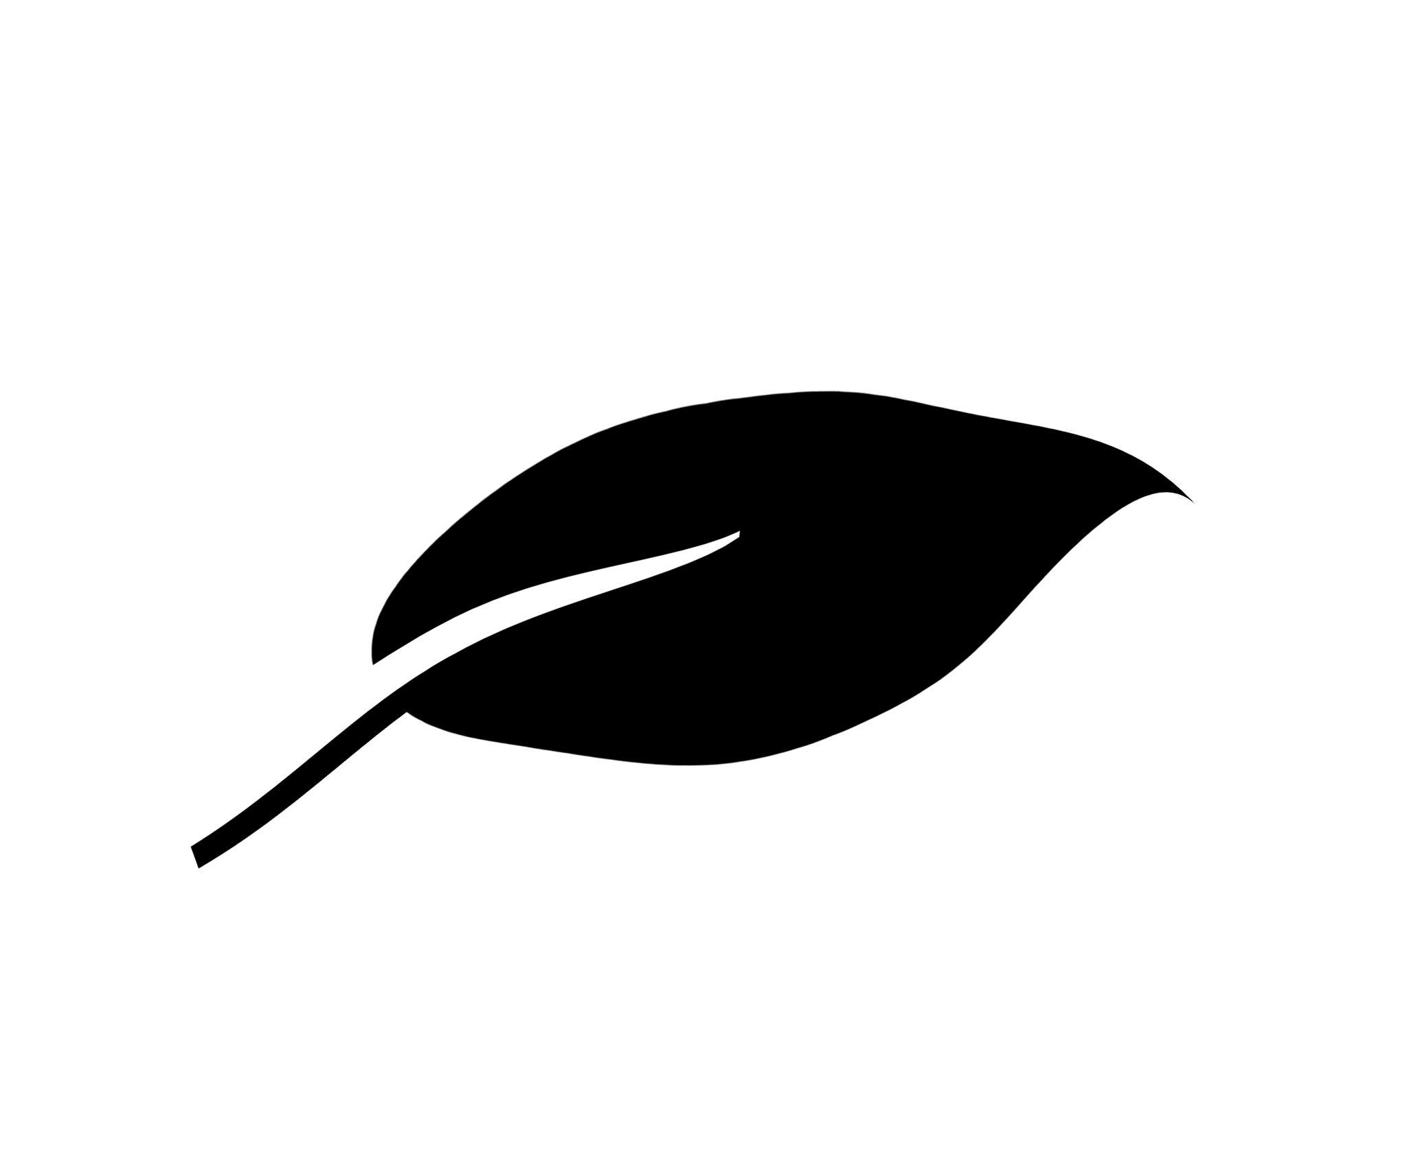

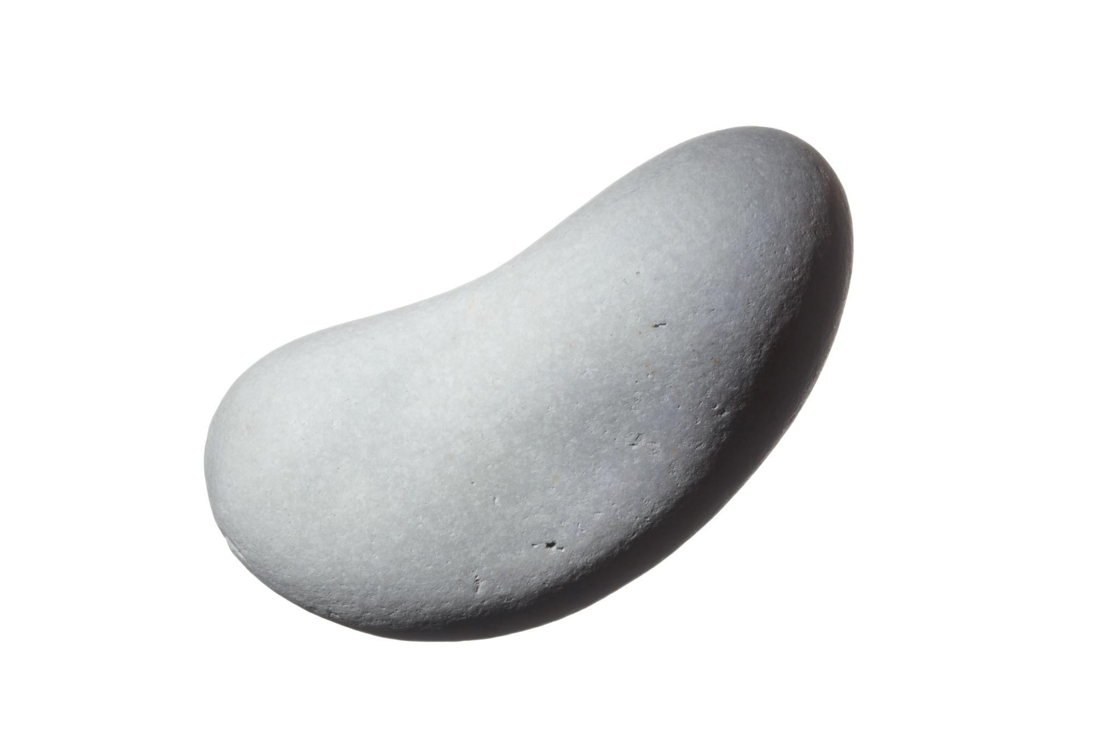
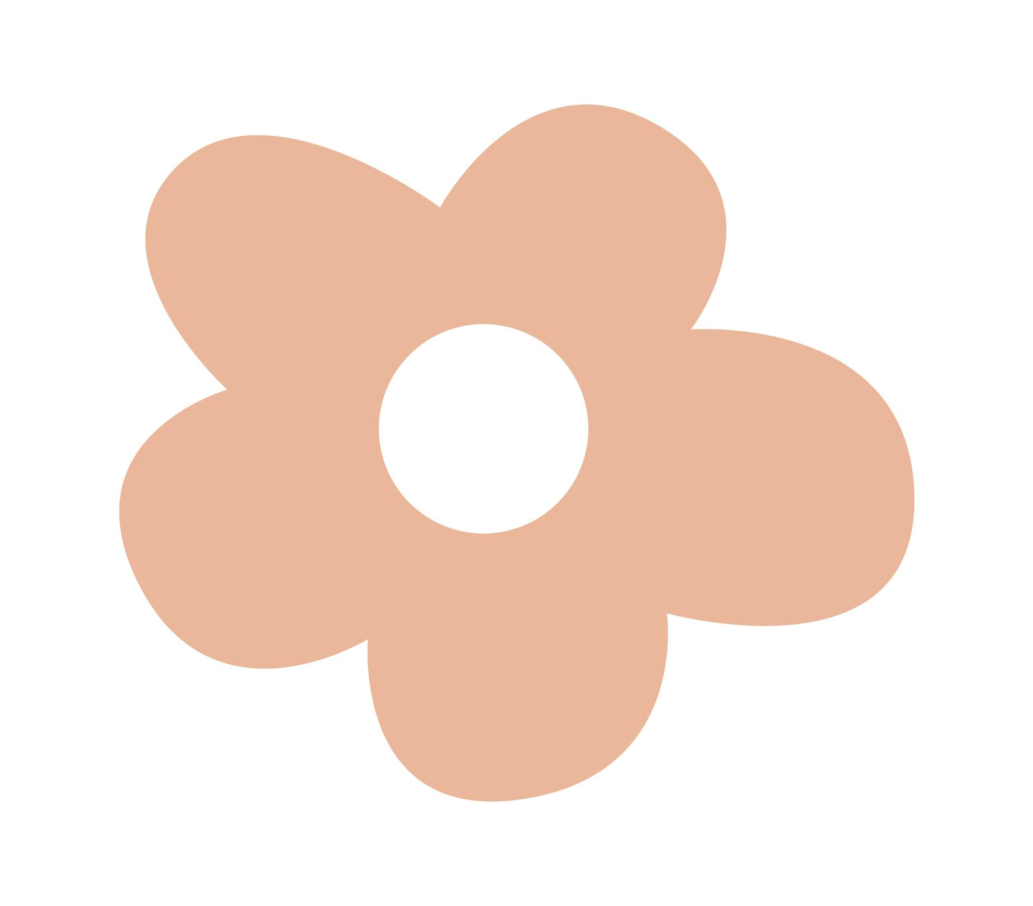

Examples
# Source: AI Source: Provided by: [Data Path: Persons Table -> ID Column: 1, Name_En Column: Motasem Essam] -> From: [ChatGPT] on [7/25/2026]
A leaf does not normally have perfectly straight sides or mathematically regular angles. Its boundary may gradually curve and vary.
A cloud can have an irregular boundary consisting of several connected curves.

Free-Form Organic Shapes
# Source: AI Source: Provided by: [Data Path: Persons Table -> ID Column: 1, Name_En Column: Motasem Essam] -> From: [ChatGPT] on [7/25/2026]
Free-Form Organic Shapes are irregular shapes created without following a strict geometric construction.
They may be:
- Abstract
- Artistic
- Decorative
- Random
- Flowing
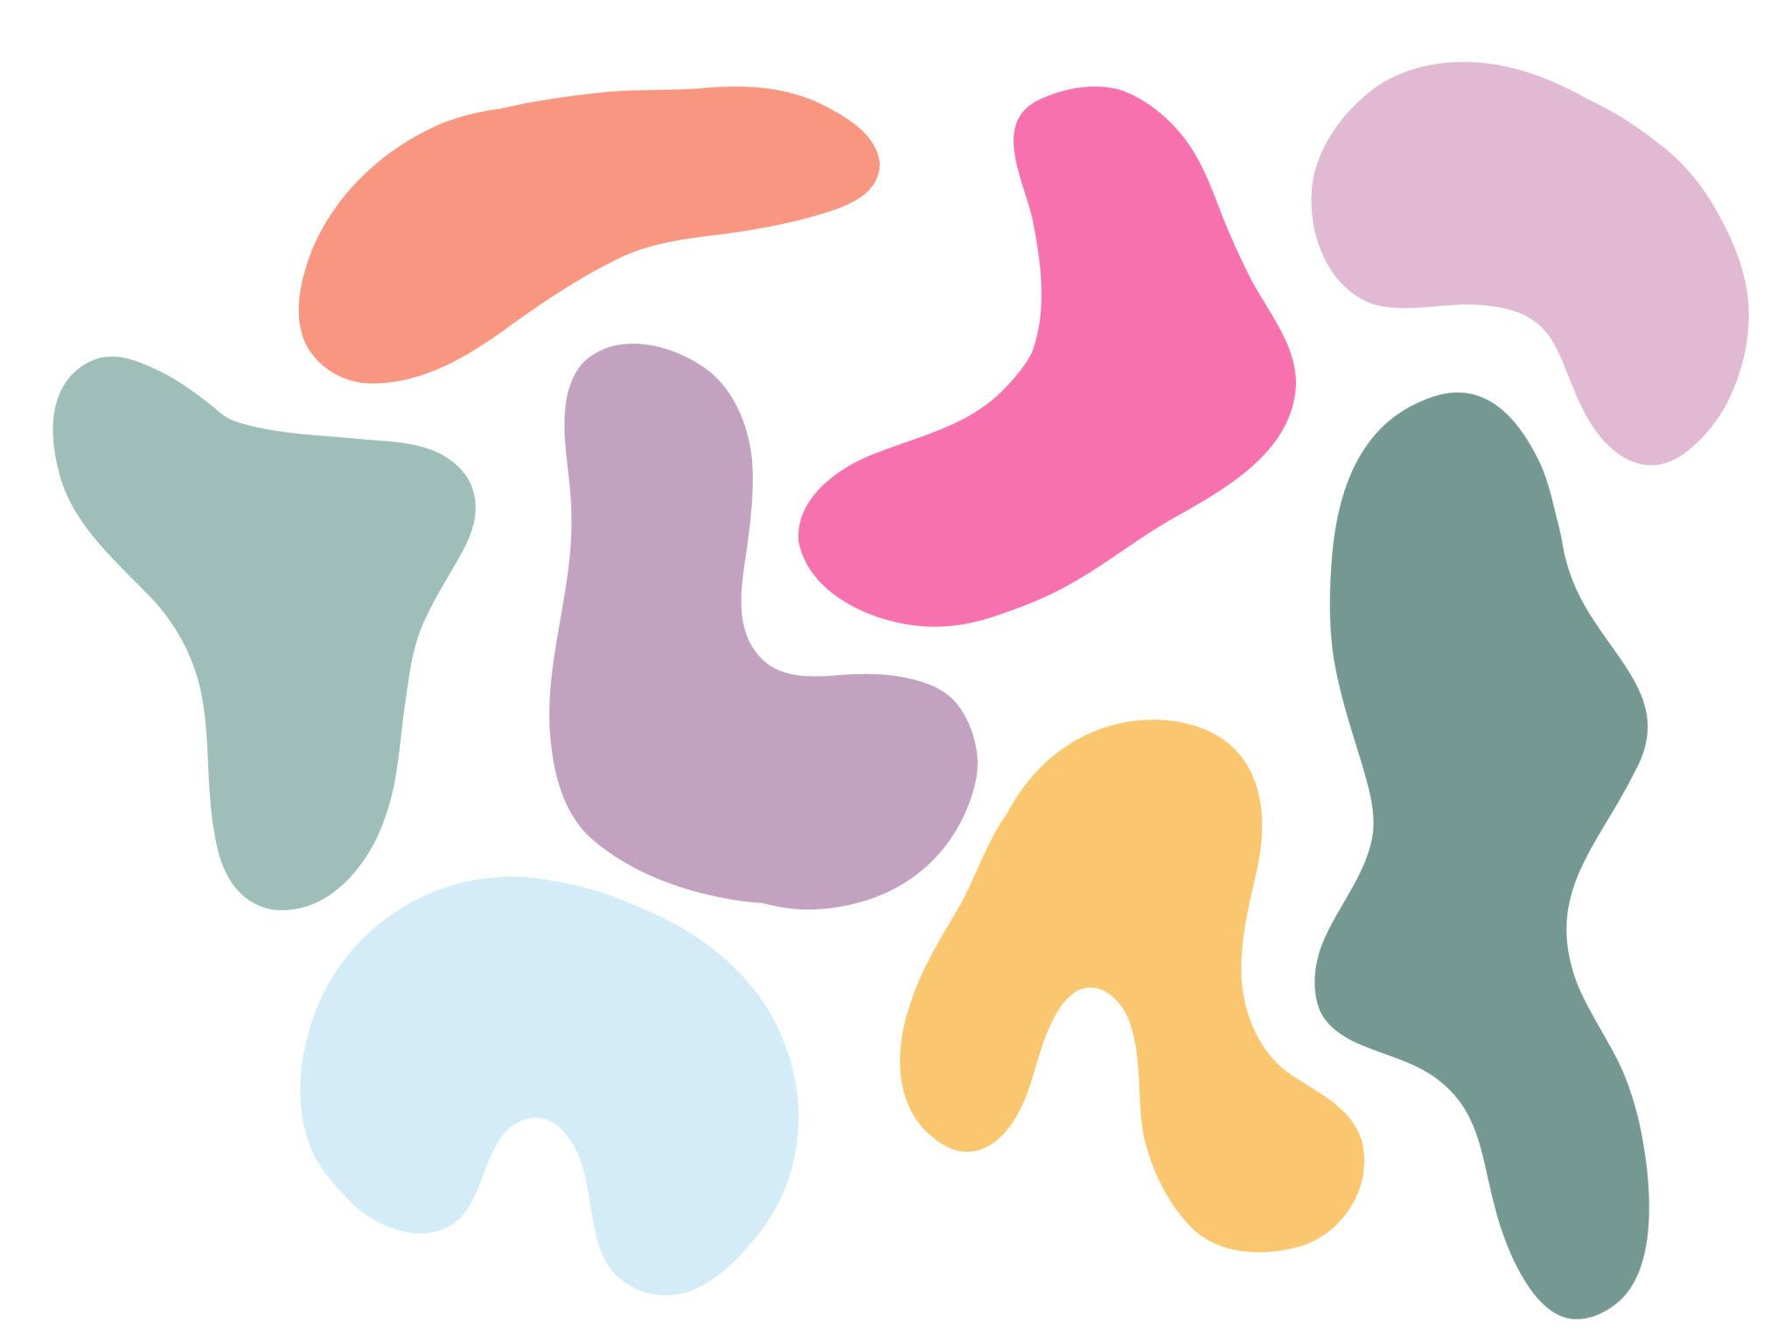
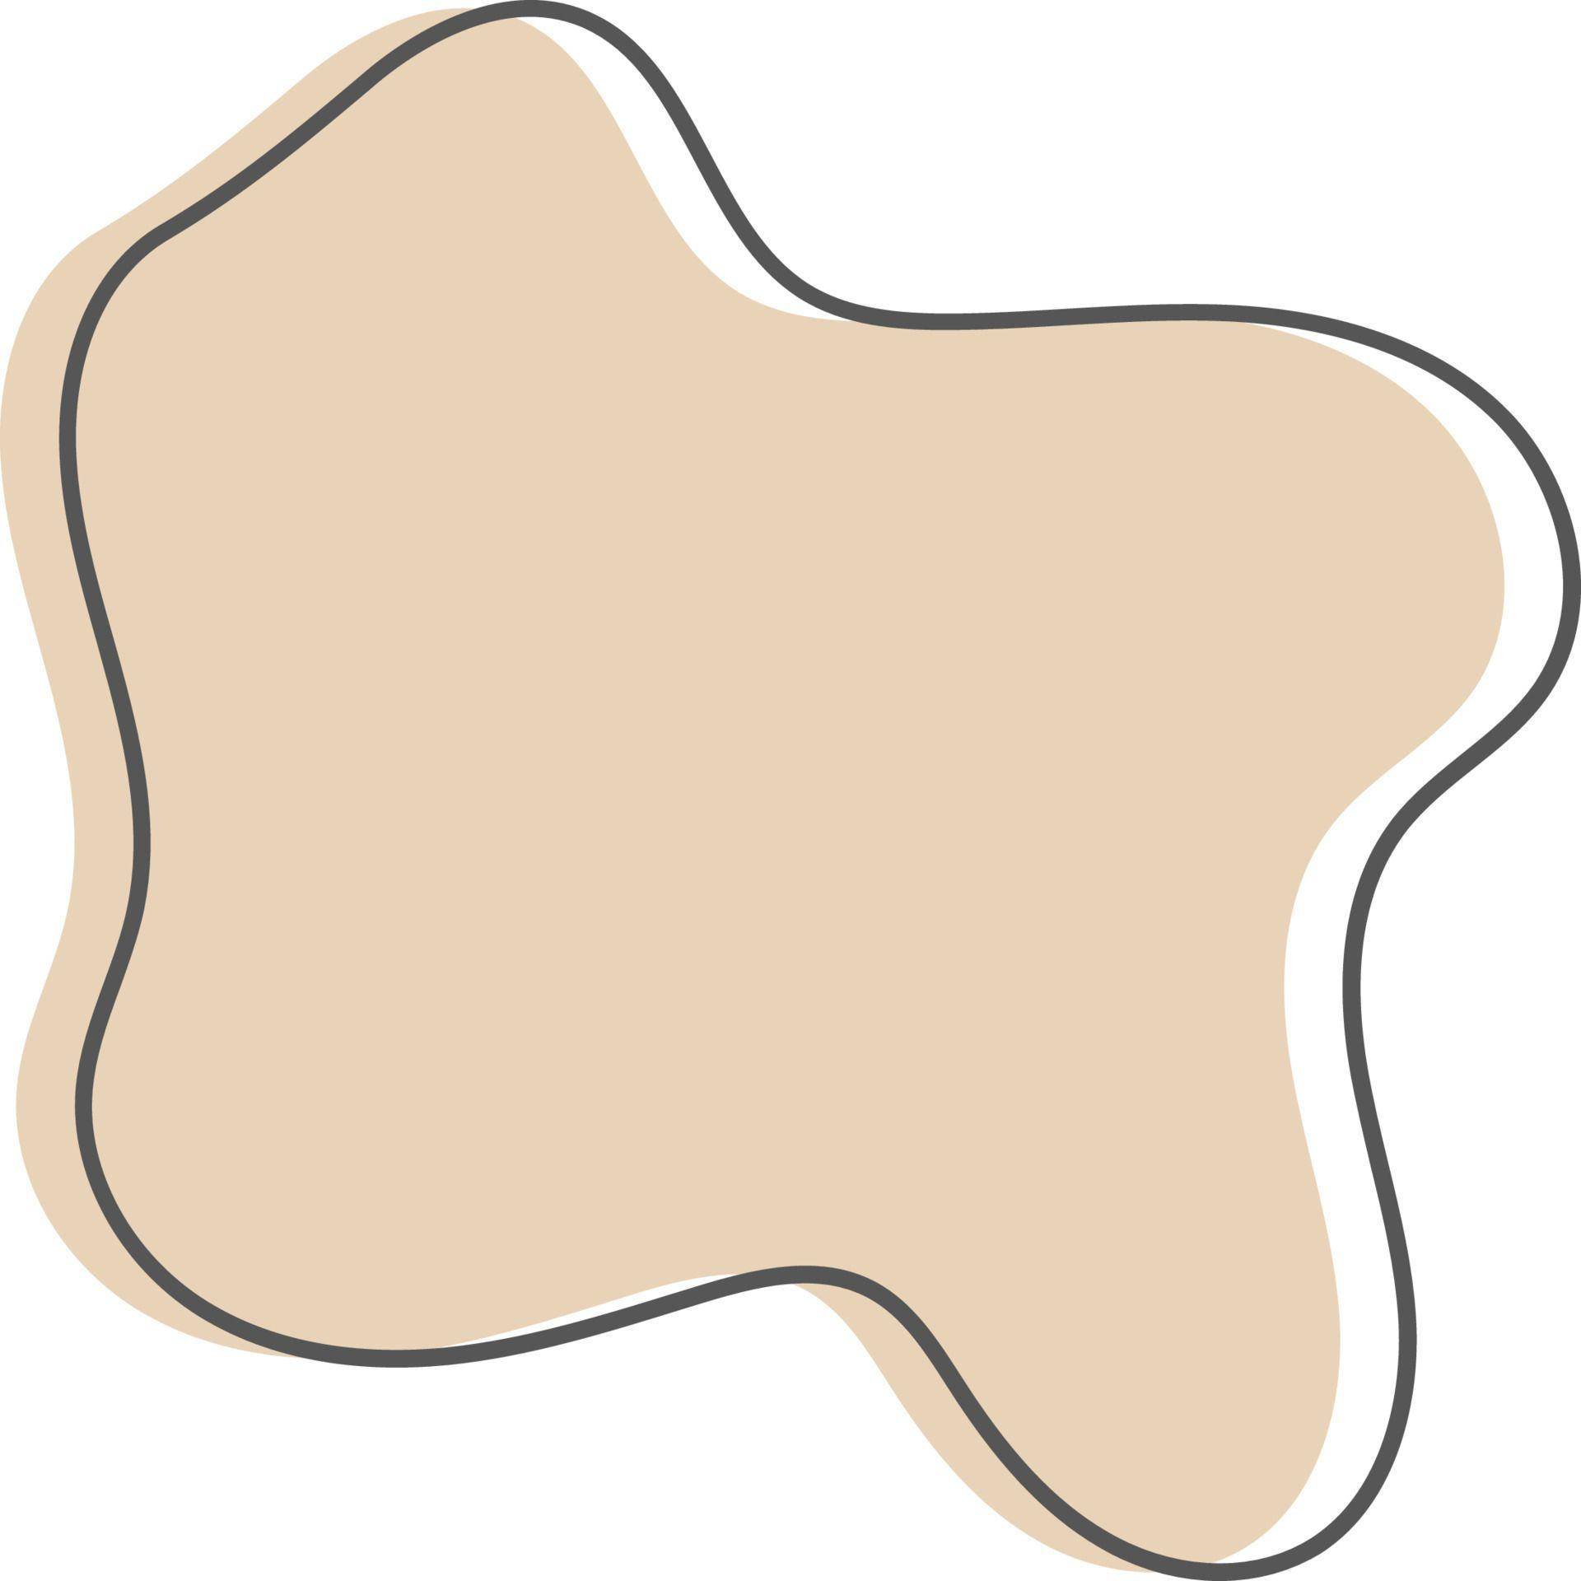
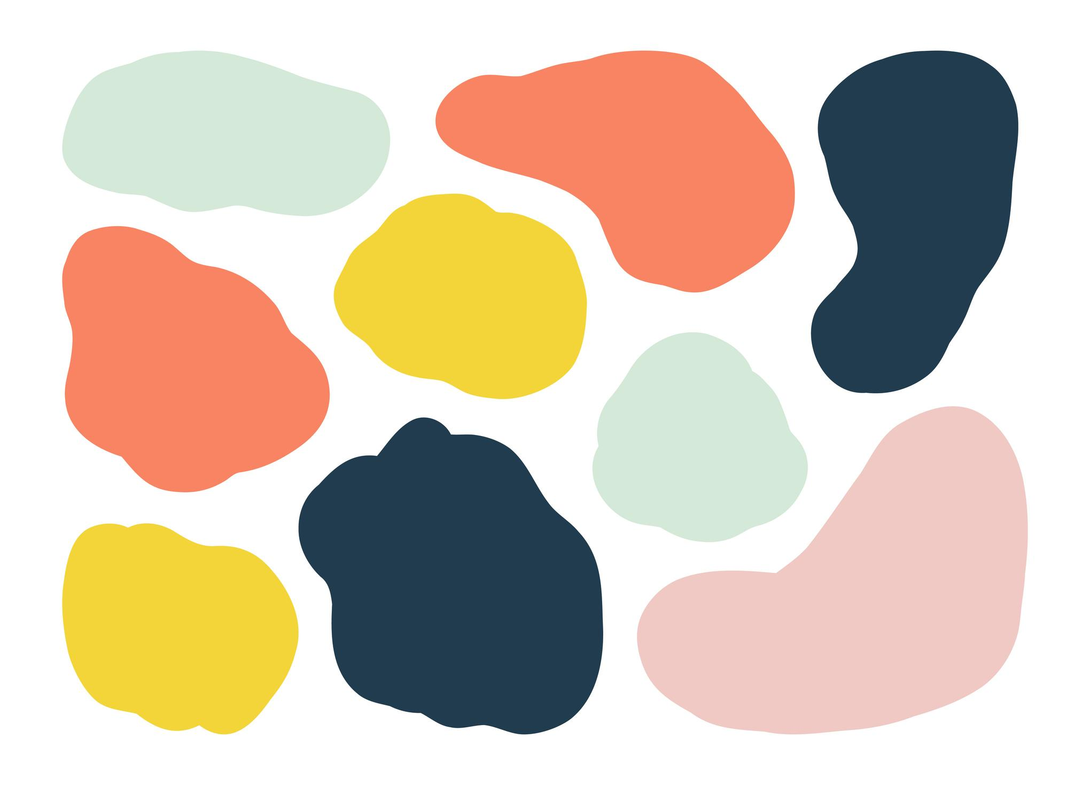
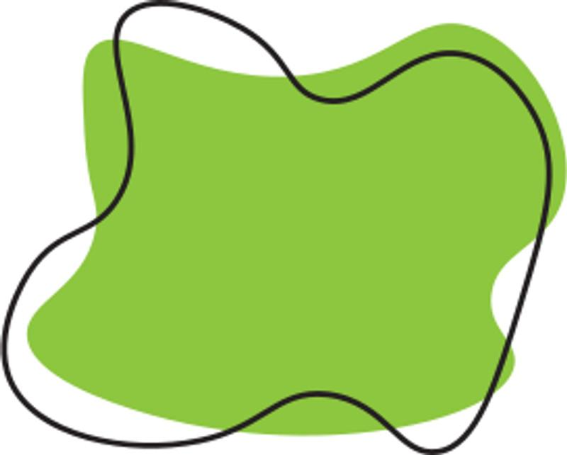
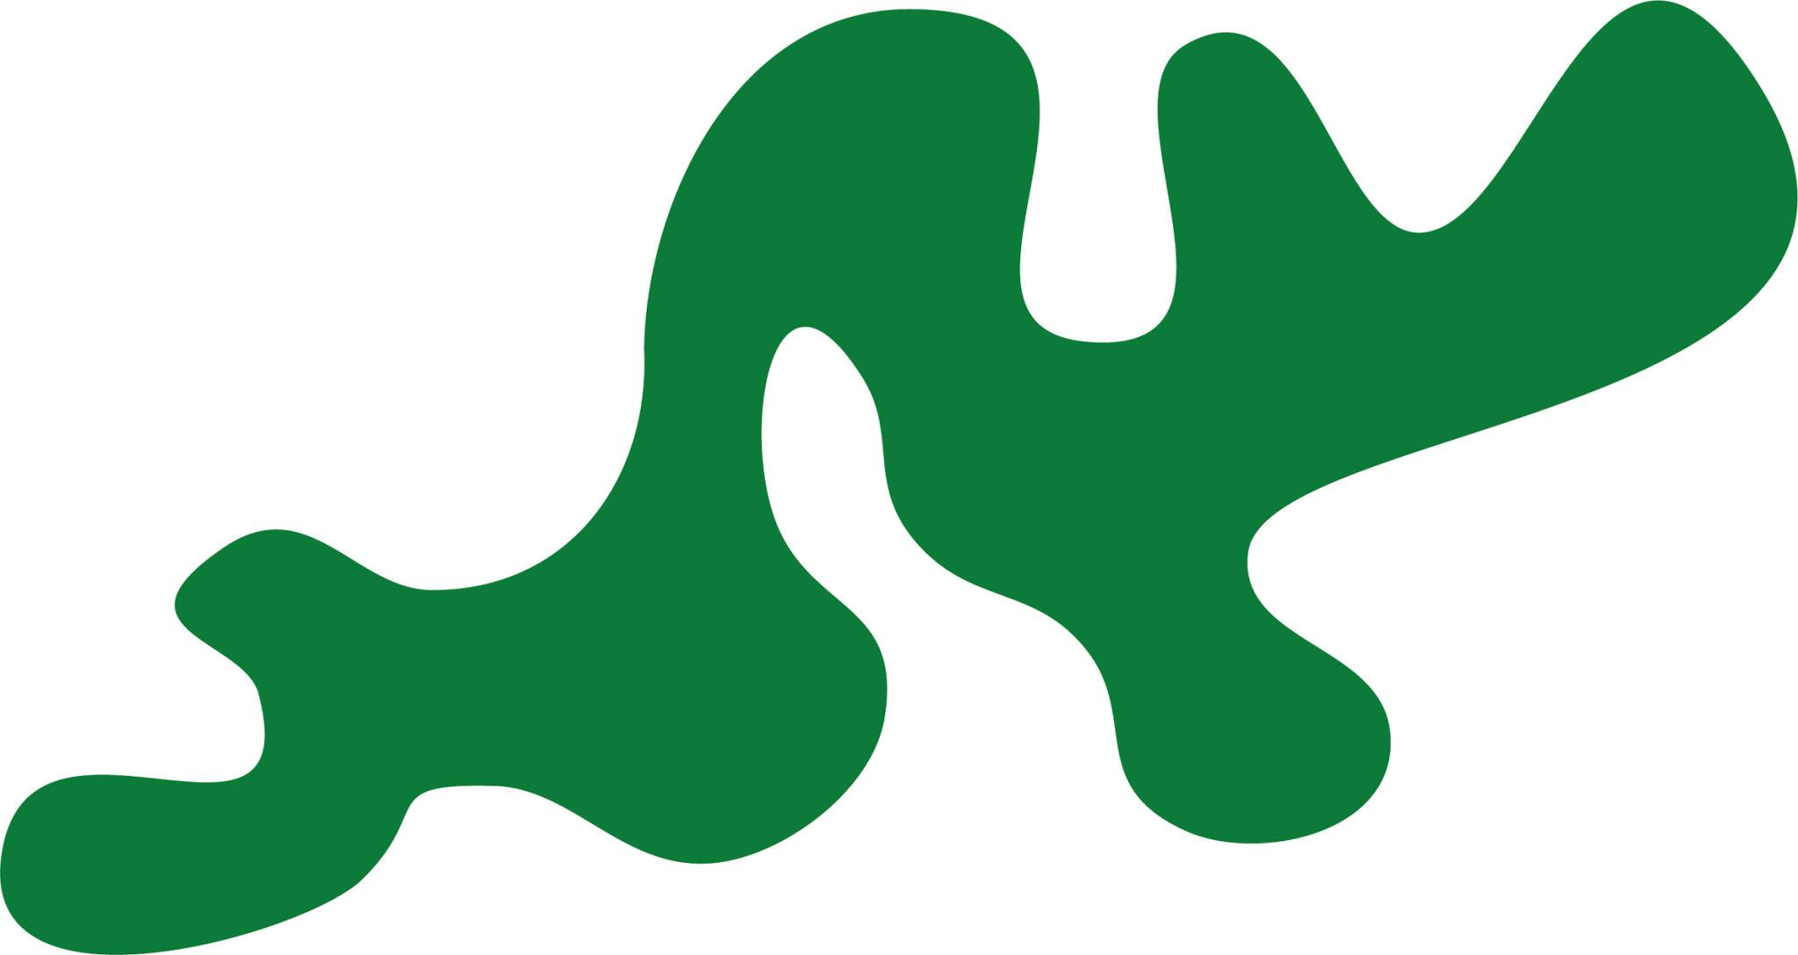
For example:
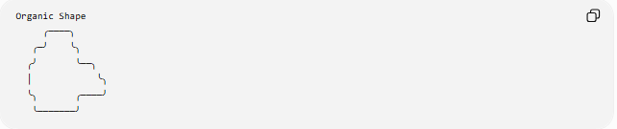
Organic Shape
╭────╮
╭─╯ ╰╮
╭╯ ╰──╮
│ ╰╮
╰╮ ╭────╯
╰───────╯
The exact boundary is not determined by a standard geometric formula.

Curvilinear Organic Shapes
# Source: AI Source: Provided by: [Data Path: Persons Table -> ID Column: 1, Name_En Column: Motasem Essam] -> From: [ChatGPT] on [7/25/2026]
Curvilinear Organic Shapes are organic shapes whose boundaries are primarily composed of curves.
They may contain:
- Smooth curves
- Wavy curves
- Rounded contours
- Irregular arcs
- Compound curves
Examples include:
- Clouds
- Water droplets
- Petals
- Amoeba-like forms
- Smooth stones
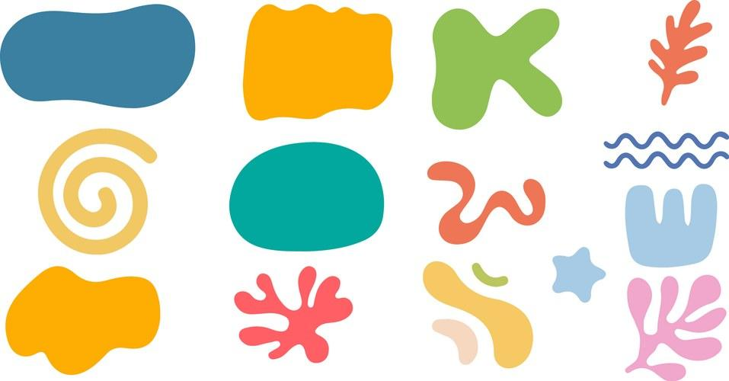
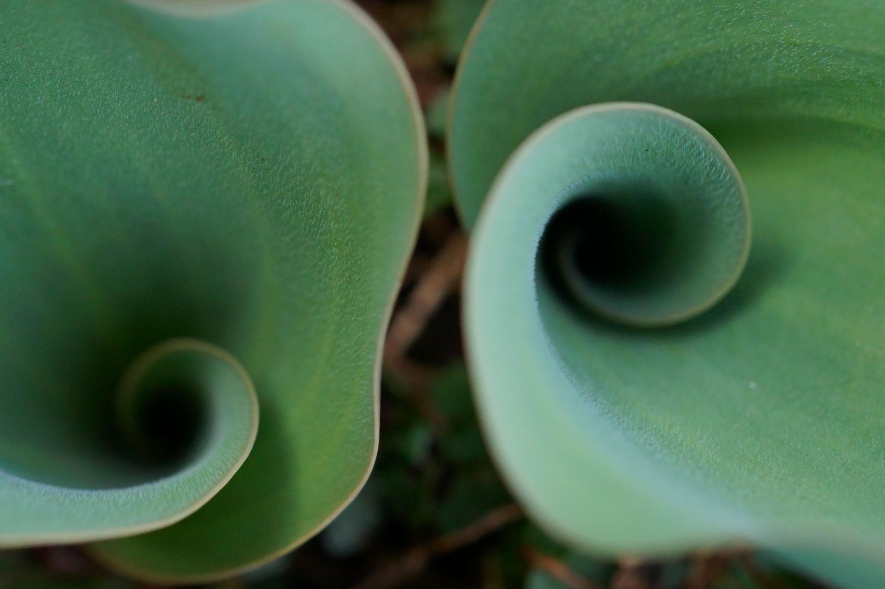
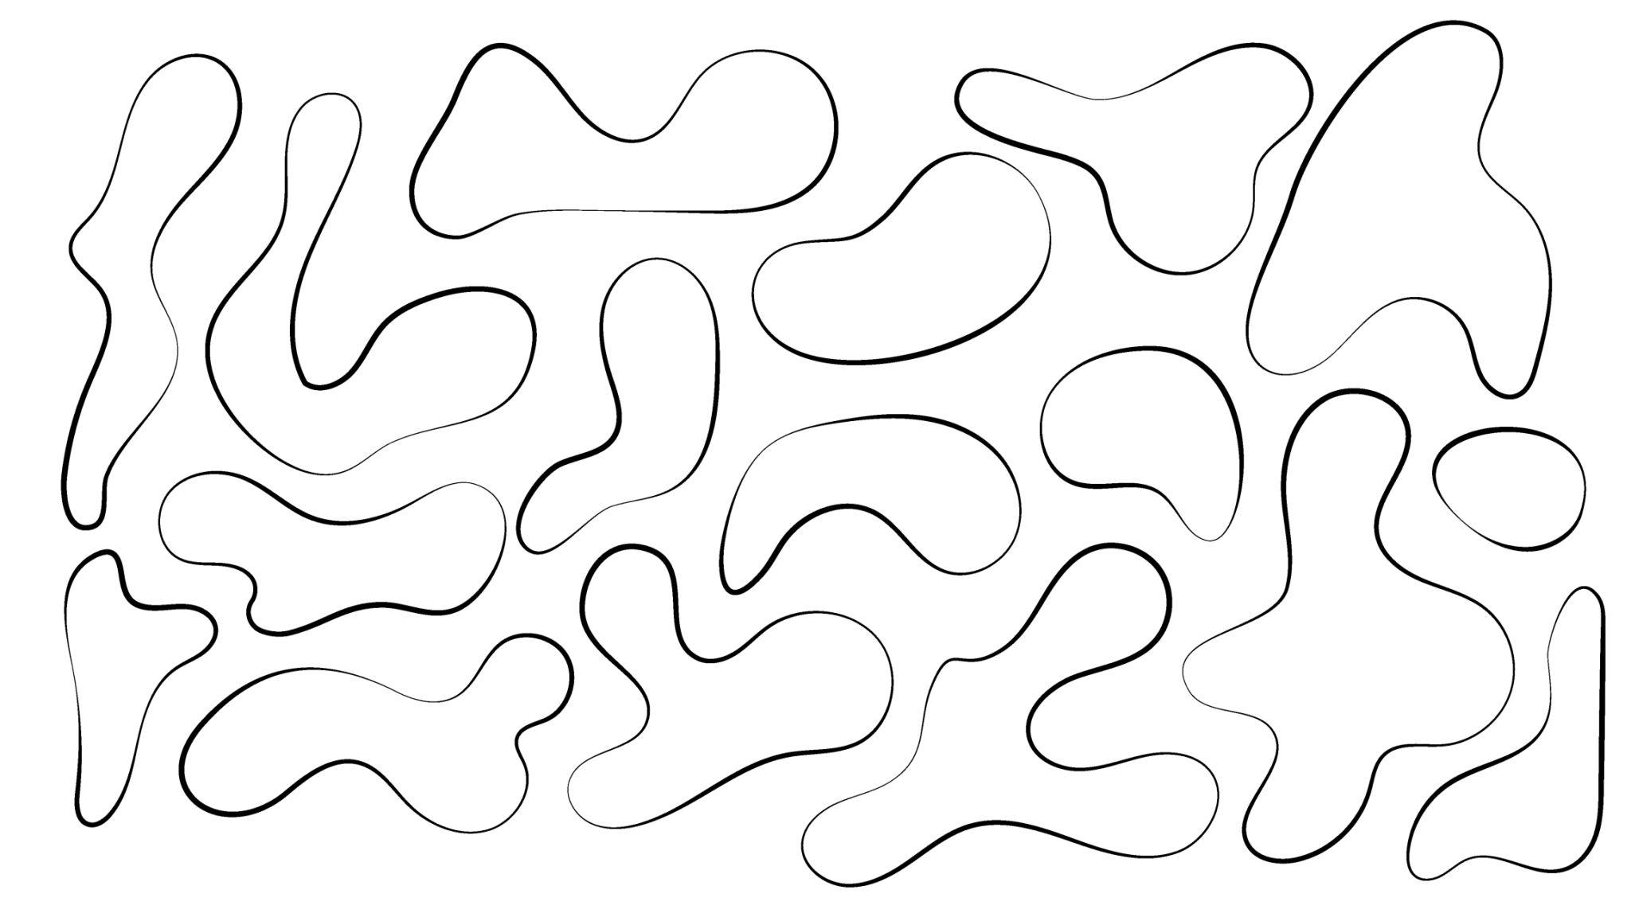
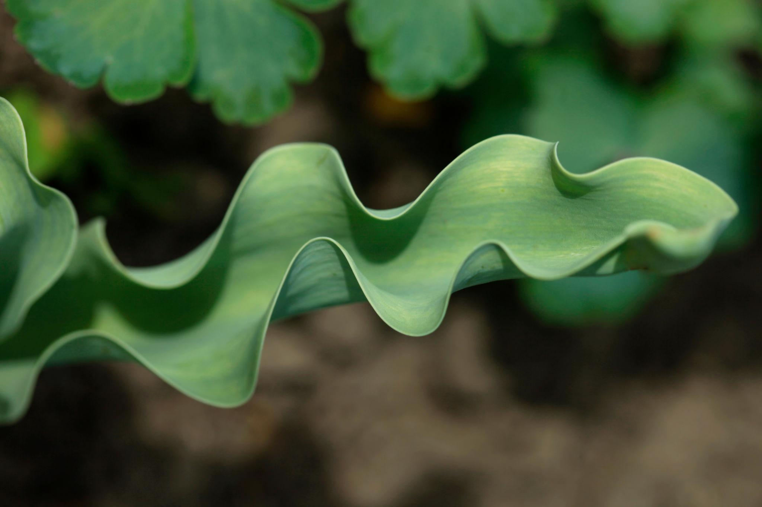
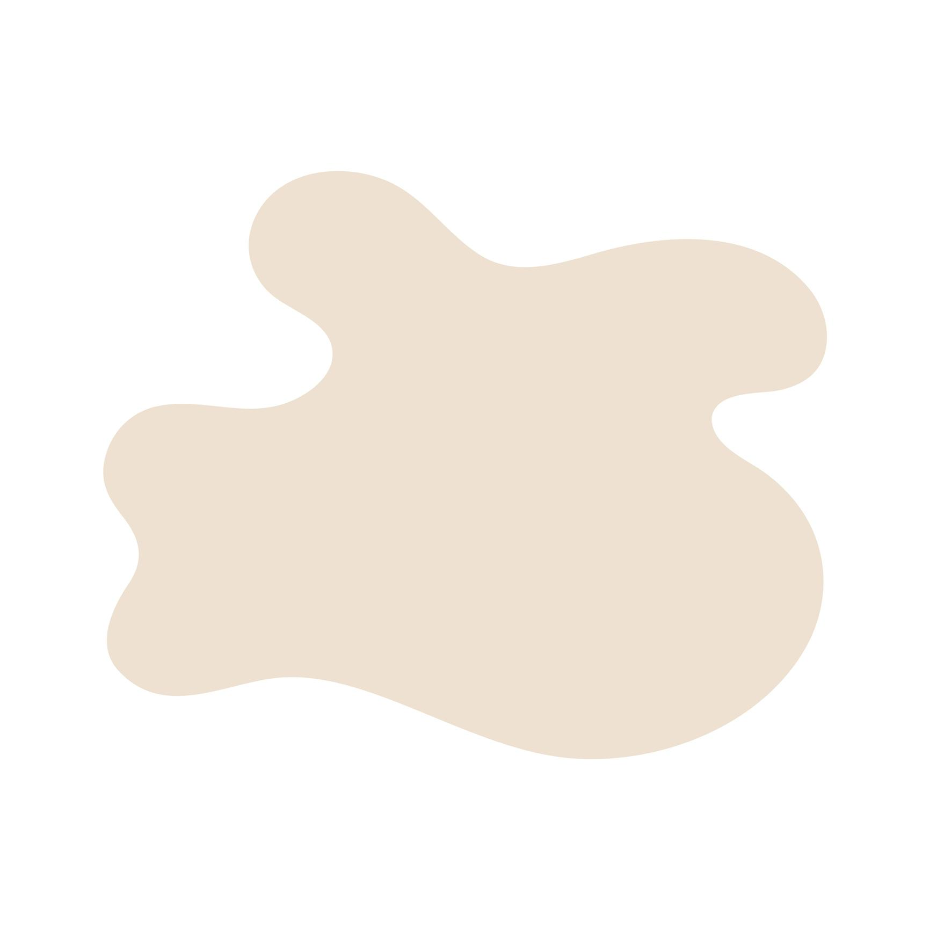

Irregular Organic Shapes
# Source: AI Source: Provided by: [Data Path: Persons Table -> ID Column: 1, Name_En Column: Motasem Essam] -> From: [ChatGPT] on [7/25/2026]
Irregular Organic Shapes have uneven or unpredictable boundaries and do not follow a regular geometric pattern.
Examples include:
- Rocks
- Broken natural surfaces
- Tree silhouettes
- Irregular leaves
- Natural puddles
An irregular organic shape may contain both straight and curved portions.

Organic Shapes with Mixed Boundaries
# Source: AI Source: Provided by: [Data Path: Persons Table -> ID Column: 1, Name_En Column: Motasem Essam] -> From: [ChatGPT] on [7/25/2026]
Organic shapes do not necessarily have to consist entirely of curves.
An organic shape can combine:
- Straight segments
- Curved segments
- Wavy segments
- Corners
- Smooth transitions
For example, a stylized leaf could have a curved outer boundary with a small pointed section.
Therefore:
$$\boxed{\text{Organic Shape}≠\text{Curved Shape Only}}$$
The defining idea is the organic/free-form character of the overall shape, rather than the presence of curves alone.

Open and Closed Organic Shapes
# Source: AI Source: Provided by: [Data Path: Persons Table -> ID Column: 1, Name_En Column: Motasem Essam] -> From: [ChatGPT] on [7/25/2026]
Organic shapes can also be classified according to whether their boundary is closed.
Closed Organic Shapes
A closed organic shape completely encloses a region.
Examples:
- Leaf outline
- Cloud outline
- Stone outline
- Abstract blob
$$\boxed{\text{Closed Organic Shape}→\text{Encloses a Region}}$$
Open Organic Shapes
An organic shape can also have an open boundary.
Examples:
- Open flowing curves
- Free-form open outlines
- Natural-looking incomplete contours
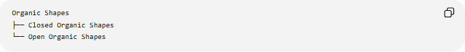
Organic Shapes
├── Closed Organic Shapes
└── Open Organic Shapes

Symmetry in Organic Shapes
# Source: AI Source: Provided by: [Data Path: Persons Table -> ID Column: 1, Name_En Column: Motasem Essam] -> From: [ChatGPT] on [7/25/2026]
Organic shapes may have:
- No symmetry
- Approximate symmetry
- One line of symmetry
- Multiple lines of symmetry
- Rotational symmetry in special cases
Most natural organic shapes are not perfectly symmetrical.
For example, a natural leaf may look approximately symmetric while having small irregularities.
Therefore:
$$\boxed{\text{Organic}⇏\text{Asymmetrical}}$$
and:
$$\boxed{\text{Organic}⇏\text{No Symmetry}}$$

Organic Shapes vs Geometric Shapes
# Source: AI Source: Provided by: [Data Path: Persons Table -> ID Column: 1, Name_En Column: Motasem Essam] -> From: [ChatGPT] on [7/25/2026]
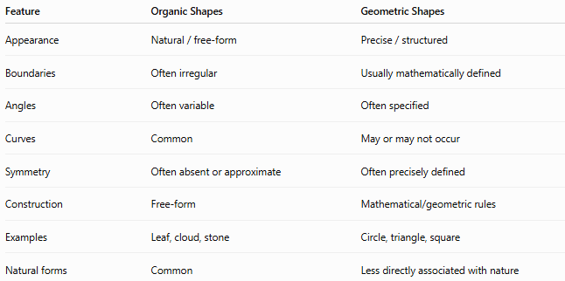
Feature | Organic Shapes | Geometric Shapes
Appearance | Natural / free-form | Precise / structured
Boundaries | Often irregular | Usually mathematically defined
Angles | Often variable | Often specified
Curves | Common | May or may not occur
Symmetry | Often absent or approximate | Often precisely defined
Construction | Free-form | Mathematical/geometric rules
Examples | Leaf, cloud, stone | Circle, triangle, square
Natural forms | Common | Less directly associated with nature
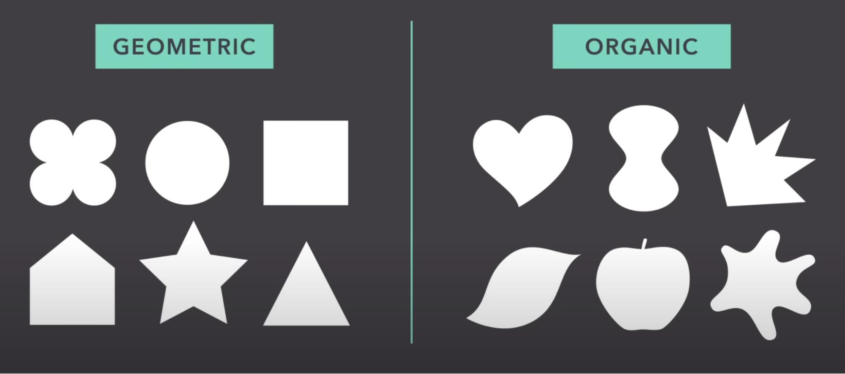
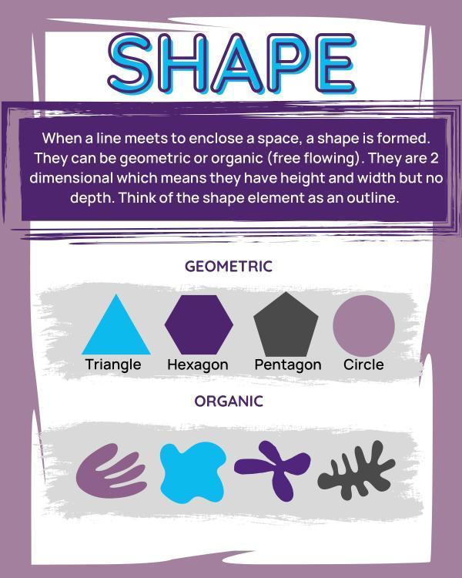
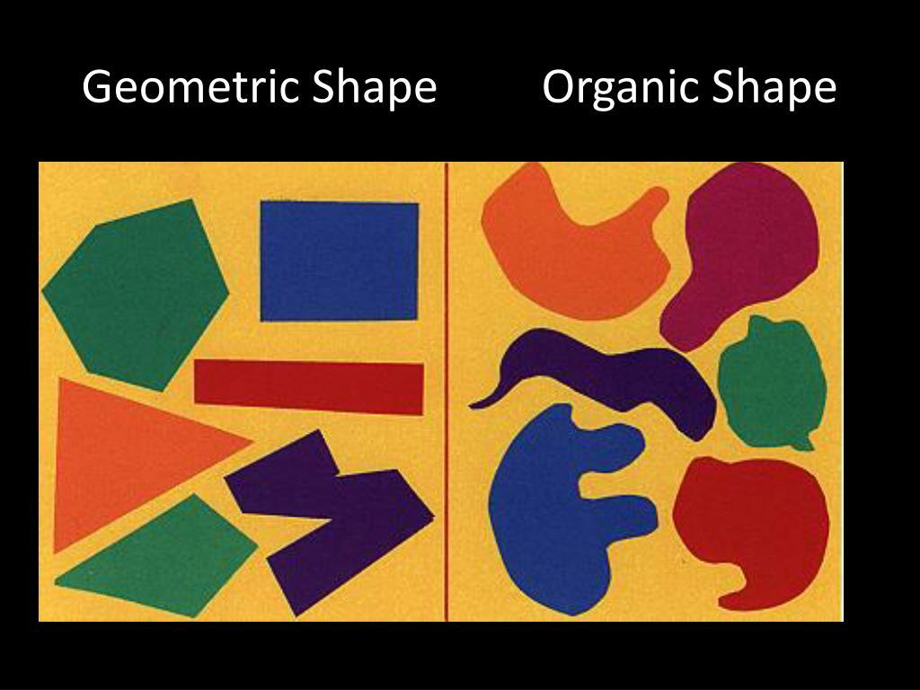
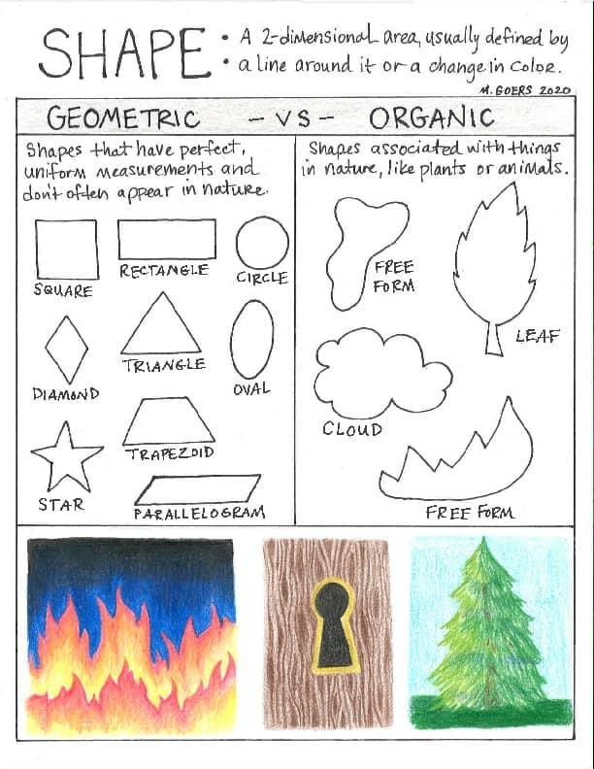
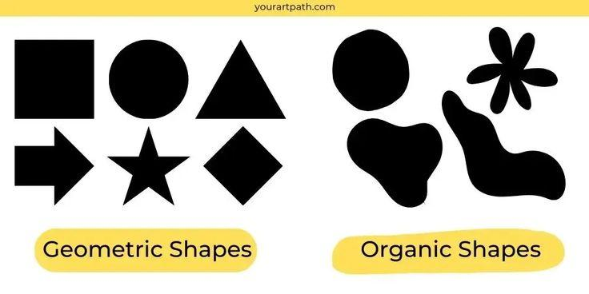

Important Distinction: Organic vs Irregular Geometric
# Source: AI Source: Provided by: [Data Path: Persons Table -> ID Column: 1, Name_En Column: Motasem Essam] -> From: [ChatGPT] on [7/25/2026]
An irregular geometric shape and an organic shape are not necessarily the same thing.
For example, an irregular pentagon is still geometric because it has:
- Five sides
- Five vertices
- Straight edges
- A polygonal structure
An organic shape may have a completely free-form boundary without a fixed number of sides.
Example
Irregular pentagon:
$$\boxed{\text{Geometric}}$$
Irregular leaf-like outline:
$$\boxed{\text{Organic}}$$
Thus:
$$\boxed{\text{Irregular}≠\text{Organic}}$$

Organic Shapes in Geometry
# Source: AI Source: Provided by: [Data Path: Persons Table -> ID Column: 1, Name_En Column: Motasem Essam] -> From: [ChatGPT] on [7/25/2026]
In elementary geometry, "organic shape" is primarily a descriptive classification, rather than a strict mathematical category.
Unlike a triangle or circle, an organic shape does not have one universal mathematical definition.
For example, its boundary may be represented mathematically using:
- Parametric curves
- Splines
- Bézier curves
- Piecewise curves
- Implicit curves
But the shape itself is classified as organic based mainly on its form and appearance.

Organic Shape Classification
# Source: AI Source: Provided by: [Data Path: Persons Table -> ID Column: 1, Name_En Column: Motasem Essam] -> From: [ChatGPT] on [7/25/2026]
A useful classification for a shape knowledge system is:
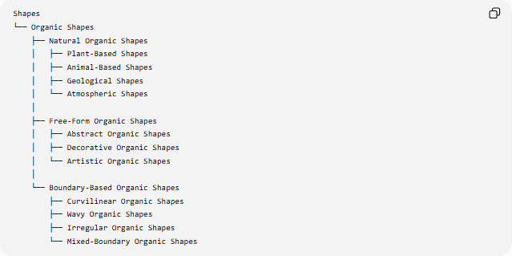
Shapes
└── Organic Shapes
├── Natural Organic Shapes
│ ├── Plant-Based Shapes
│ ├── Animal-Based Shapes
│ ├── Geological Shapes
│ └── Atmospheric Shapes
│
├── Free-Form Organic Shapes
│ ├── Abstract Organic Shapes
│ ├── Decorative Organic Shapes
│ └── Artistic Organic Shapes
│
└── Boundary-Based Organic Shapes
├── Curvilinear Organic Shapes
├── Wavy Organic Shapes
├── Irregular Organic Shapes
└── Mixed-Boundary Organic Shapes

Examples
# Source: AI Source: Provided by: [Data Path: Persons Table -> ID Column: 1, Name_En Column: Motasem Essam] -> From: [ChatGPT] on [7/25/2026]
Natural examples
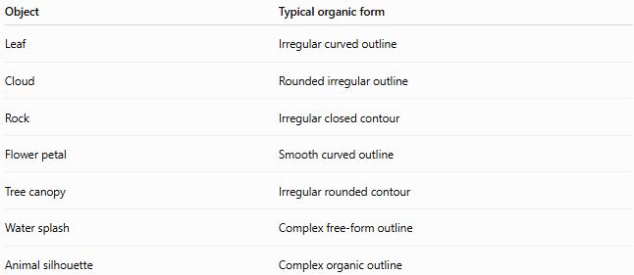
Object | Typical organic form
Leaf | Irregular curved outline
Cloud | Rounded irregular outline
Rock | Irregular closed contour
Flower petal | Smooth curved outline
Tree canopy | Irregular rounded contour
Water splash | Complex free-form outline
Animal silhouette | Complex organic outline
Artificial examples
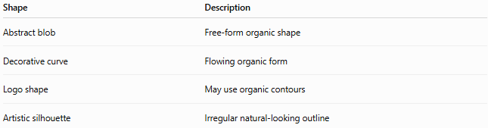
Shape | Description
Abstract blob | Free-form organic shape
Decorative curve | Flowing organic form
Logo shape | May use organic contours
Artistic silhouette | Irregular natural-looking outline

Organic Shape vs Free-Form Shape
# Source: AI Source: Provided by: [Data Path: Persons Table -> ID Column: 1, Name_En Column: Motasem Essam] -> From: [ChatGPT] on [7/25/2026]
These terms are related but not identical.
Free-form shape emphasizes that the shape is not constrained by standard geometric rules.
Organic shape emphasizes a natural, irregular, flowing, or natural-looking appearance.
Therefore, a free-form shape can be organic, but not every free-form shape necessarily has a natural appearance.

Key Properties
# Source: AI Source: Provided by: [Data Path: Persons Table -> ID Column: 1, Name_En Column: Motasem Essam] -> From: [ChatGPT] on [7/25/2026]
An organic shape may have:
$$\boxed{\text{Irregular Boundary}} \\ \boxed{\text{Free-Form Contour}} \\ \boxed{\text{Curved or Mixed Edges}} \\ \boxed{\text{Variable Direction}} \\ \boxed{\text{Natural Appearance}}$$
But none of these properties is individually required for every organic shape.

Key Points
# Source: AI Source: Provided by: [Data Path: Persons Table -> ID Column: 1, Name_En Column: Motasem Essam] -> From: [ChatGPT] on [7/25/2026]
- Organic shapes are generally natural-looking, irregular, or free-form shapes.
- They commonly resemble forms found in nature.
- They may be closed or open.
- They may contain curves, straight portions, or both.
- They may be symmetrical, approximately symmetrical, or asymmetrical.
- Organic shapes do not have to represent actual natural objects.
- An irregular geometric shape is not automatically an organic shape.
- "Organic shape" is primarily a descriptive classification rather than a strict mathematical category.

Conclusion
# Source: AI Source: Provided by: [Data Path: Persons Table -> ID Column: 1, Name_En Column: Motasem Essam] -> From: [ChatGPT] on [7/25/2026]
Organic Shapes are shapes characterized by natural, irregular, flowing, or free-form forms.
A useful classification is:
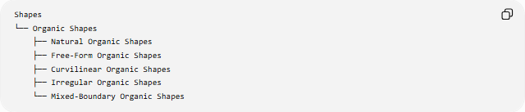
Shapes
└── Organic Shapes
├── Natural Organic Shapes
├── Free-Form Organic Shapes
├── Curvilinear Organic Shapes
├── Irregular Organic Shapes
└── Mixed-Boundary Organic Shapes
The fundamental distinction is:
$$\boxed{\text{Geometric Shapes}→\text{Mathematically structured}} \\ \boxed{\text{Organic Shapes}→\text{Natural or free-form}}$$

